SEN Information Report 22-23
East Anstey Primary School is a very small, rural primary school. We aim to be an inclusive school, providing appropriately for children with special educational needs (SEND) and disabilities within our mainstream setting, to ensure that they attain their full potential.
The needs of our children can best be described as falling into one or more of the following areas:

- Communication and interaction
- Cognition and learning
- Social, emotional and mental health difficulties
- Sensory and/or physical needs

How does the school identify pupils needing additional support?
East Anstey Primary School has a graduated response to SEND, aiming to identify needs early and put into place support that ensures the child makes the best possible progress. We do this through monitoring the progress of all children regularly and identifying those that have a significantly greater difficulty in learning than the majority of children the same age.
We use standard assessments, teacher assessments and observations to identify children’s current levels of attainment and skills and when necessary extra support is planned. Where pupils continue to make inadequate progress, despite high quality teaching targeted at their needs, the SENDCO will work with the teacher and parents to determine whether the child has a significant learning difficulty. This may also involve external agencies who will complete more specialised assessments.

Regular meetings with parents are used to listen to their concerns, draw on their knowledge and experience of their child and then draw up a plan of action to shape the support and strategies put into place. This plan is then regularly monitored to ensure that it is working for the child and progress is being made; any changes necessary can then be discussed and agreed with parents.

How does the school evaluate the effectiveness of its provision for pupils with SEND?
The Senior Leadership Team (SLT), along with the SENDCO, closely monitor the progress of children with SEND through either the Individual Education programme (IEP) system, or a My Plan which is used for those children requiring support from external agencies. These are written and reviewed regularly to ensure that children are making progress with the appropriate support needed.
Throughout the term progress is monitored to see how effective support is in enabling children to make good progress. The SENDCO feeds back regularly to the governors through the SEND link governor.

What are the school’s arrangements for assessing and reviewing the progress of pupils with special educational needs?
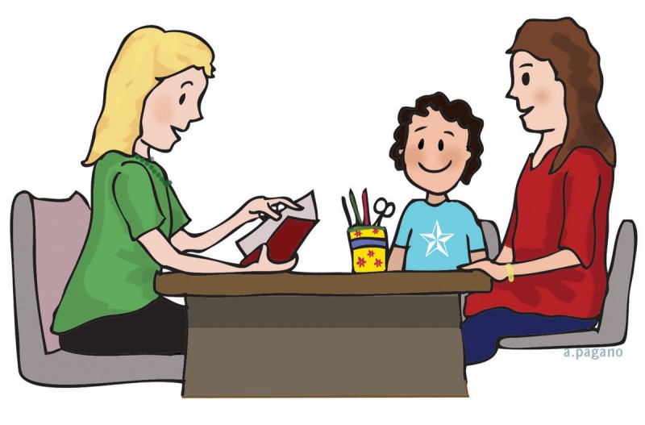
Our assessment procedures are rigorous, ensuring that teachers share data with senior staff members regularly to ensure that progress can be monitored. There are three parents’ evenings a year, where teachers will discuss progress with parents, review how support is helping them to achieve this and discuss how this can be continued at home. These discussions will largely be reflected through the IEP process and sometimes a home/school book is introduced to ensure that both school and home are able to support each other.
Some children may require a more detailed “My Plan”, agreed with parents and other professionals in Team Around the Family meetings (TAF meetings). These are reviewed termly according to the ‘assess, plan, do, review’ cycle, with all those involved to ensure that the child is making the best progress possible.
Children with an Education, Health and Care plan (EHCP), or a statement, will also have an annual review meeting where progress over the year is discussed in detail, and plans for the next 12 months agreed with parents and children.

What is the school’s approach to teaching pupils with special educational needs?
In school we aim to include every child in as much learning as possible alongside their peers in the mainstream classroom. To enable this to work we provide a range of additional support, such as resources and targeted support from both class teachers and Teaching assistants (TA) to support children with SEND.
We recognise that some children may need additional to or different provision for varying amounts of their timetable, therefore Teaching assistants may be used to put intervention plans into place or ensure that the curriculum is adapted to meet the needs of individual children.

How does the school adapt the curriculum and learning environment for pupils with special educational needs?
Each teacher differentiates their lessons to suit the range of abilities and needs within their classroom. The teacher will share their planning with any TA’s that are working with groups or children with SEND and ensure that any extra or different resources are available. Any specific strategies needed are explained to TA’s and training given if needed.
Some of the ways in which we adapt our learning environment for pupils with special educational needs are:
Visual timetable
Coloured paper/ coloured overlays
Coloured screens
Low ability- high interest reading books
Ability to access equipment
Sensory equipment such as wobble cushions, pencil grips and fidget toys
Wheelchair access to the vast majority of the school
Ensuring after school provision is able to be accessed by all

What additional support for learning is available to pupils with special educational needs?
Teachers encourage children to learn in a variety of ways, where possible children with SEND will be given the opportunity to work in a practical way.
Where gaps have been identified, children will be able to work in groups on specific areas. This may be short term intervention or longer term, where children follow a specific programme.
Depending on the level of need, children may work in small groups or on a one-to-one with either a TA or a teacher.
The school is able to call upon a number of outside agencies, with parental permission, to ask for assessment and guidance. Using these plans and recommendations, TA’s can work with children to support their progress.
These agencies include:
Educational Psychology Service
Devon Information Advice and Support (DIAS- for parents)
SALT (Speech and Language Therapy)
SEMH (Social, emotional and mental health team)
Social care services
Children and Family Health Devon (including Occupational Therapy and Children and Adolescent Mental Health Service- CAMHS)
School Nurse

How does the school enable pupils with special educational needs to engage in the activities of the school (including physical activities) together with children who do not have special educational needs?
All children with SEND are part of a mainstream class, including those who work with TA’s on a one to one basis. This ensures that there are opportunities for all children to be involved in outings, residential trips and after school clubs. Any alterations that are required will be taken into account during planning to ensure individual needs are met.

What support is available for improving the emotional, mental and social development of pupils with special educational needs?
We recognise that some children have extra emotional and social needs that may need specific intervention to ensure that they are able to fulfil their potential. These needs can be shown in a number of ways, such as: behavioural difficulties, anxiousness and struggling to communicate effectively.
All classes follow a structured PSHE curriculum, allowing time to discuss issues as they arise alongside areas such as keeping safe, who to trust, losing someone special, friendship and anti-bullying.
Sometimes a ‘designated person’ is used to enable the child to have someone they are able to talk to whenever the need arises. This person may be someone that they have regular mentoring sessions with.
Social skills groups are used to help children settle into the school day and be given extra opportunities to understand feelings and develop good relationships.
If a child needs further support, with parental permission, an Individual behaviour programme will be put into place, moving onto a My Plan if extra support from other agencies is needed.

Who can you contact to discuss concerns in relation to SEND?
If you have any concerns that your child may have special education needs, or wish to discuss their provision and/or progress please make an appointment to speak to the class teacher first.
You can also speak to either our SENDCO, Claire Partridge, by making an appointment with the school office, or Jenny Scandrett (Head of Teaching and Learning).

What training do staff supporting children with SEND have?
All teachers are teachers of children with special educational needs, therefore we aim to provide continuous training and support so that all staff are equipped to deal with a diverse range of needs.
Teachers have access to the SENDCO, who has achieved the National Award in Special Educational Needs Coordination, attends regular update sessions run by Devon County and is the Mental Health Champion, for guidance or support with putting new strategies into place. We also have the opportunity to obtain training and guidance from outside agencies.
The school has a number of TA’s trained in specific interventions, such as Counting to calculating, passive intervention and prevention strategies (PIPs), Attachment based mentoring, Speech and language across the phases, Lego therapy and Funfit. These are used widely across all age ranges.

How will equipment and facilities to support children and young people with special educational needs be secured?
For details of our policy on Accessibility please see our website; http://www.east-anstey-primary.devon.sch.uk

How does the school consult with young people with special educational needs and involve them in their education?
Teachers set targets with all children; this enables discussions to be had with everyone including those with SEND. The children are encouraged to assess their own performance based on their experience of previous work. Those children who are able to give their own ideas on what support they need are encouraged to do so. Where possible this information is then taken into consideration when planning for their needs.
Once a year the school encourages children to complete a child’s questionnaire, to obtain their views on school life. Children with SEND are given the opportunity to work with an adult or another child to complete this process successfully.
On all IEP and My Plans the child and family are encouraged to share their views, ensuring that the child’s voice is heard. This can be done with a trusted adult in school, at home or with someone form an external agency such as Devon Information Advice and Support (DIAS).

What are the arrangements made by the governing body relating to the treatment of complaints from parents of pupils with special educational needs concerning the provision made at the school?
Any problems can be discussed with the SENDCO or Head of Teaching and Learning in the first instance. If the problem is still not resolved then you can contact our Headteacher, by making an appointment through the school office.
You may contact the governors through our complaints procedure by writing to:
Clerk to the Governors
East Anstey Primary School
East Anstey
Devon
EX169JP

What are the contact details of support services for the parents of pupils with special educational needs?
For details of our policies on SEND, Accessibility, Inclusion and Admissions please see our website; http://www.east-anstey-primary.devon.sch.uk
From time to time we also signpost events in the area that are specifically for children with SEND. These will appear in our weekly update and on our website. Parents can also find advice on the Children and Family health Devon website https://childrenandfamilyhealthdevon.nhs.uk/

What are the school’s arrangements for supporting pupils with special educational needs in a transfer between phases of education?
Our 2-4 year olds provision is now incorporated into the school. Early Years and Infant classes work together regularly both in a dedicated unit. This helps children to see their move through early years and up through the school as a natural progression.
At times of transition to other schools additional meetings and support plans are put into place for children and their families, as early as is possible. Where extra transition days are appropriate these can be arranged. Parents are able to request to meet with staff to discuss concerns or requirements and often staff are invited to TAF meetings to ensure that they are up to date with needs and current provision.

Where can I find out about the authority’s local offer?
Devon’s Local Offer is about providing clear, up-to-date information on the services and support for --children and young people with special educational needs and disability.
To access this please use this link:
https://new.devon.gov.uk/educationandfamilies/special-educational-needs-and-disability-send-local-offer

